**Point Of Sale Documentation**

**Desktop Application using C#**

**Author Team 1 : Mohamed Abdelwahab**

**Ahmed Eid**

**Esraa saber**

**Nashed Fekry**

**Created : October, 2023**

**Tools : Visual Studio**

**Point Of Sale**

It is a system for managing restaurants and cafes, and a set of features and requirements have been implemented within it for each of them

**Database :**

The database was created and contains the users table, the permissions table, the categories table, and the items table. The financial transaction tables were added from the payments table and the check table and the Tables table.

**The system consists of a set of interfaces :**

1- Basic interfaces.

2- The cashier interface, which is the most important screen

3- Interface for printing invoices through the application.

4- Important reports interface for each cashier program, such as sales and sales by items.

5- A login interface for all application users.

6- Determine permissions for each user of the application.

7- Adding different payment methods to the application.

8- Professional tables system through some graphics work in the application.

**ERD**

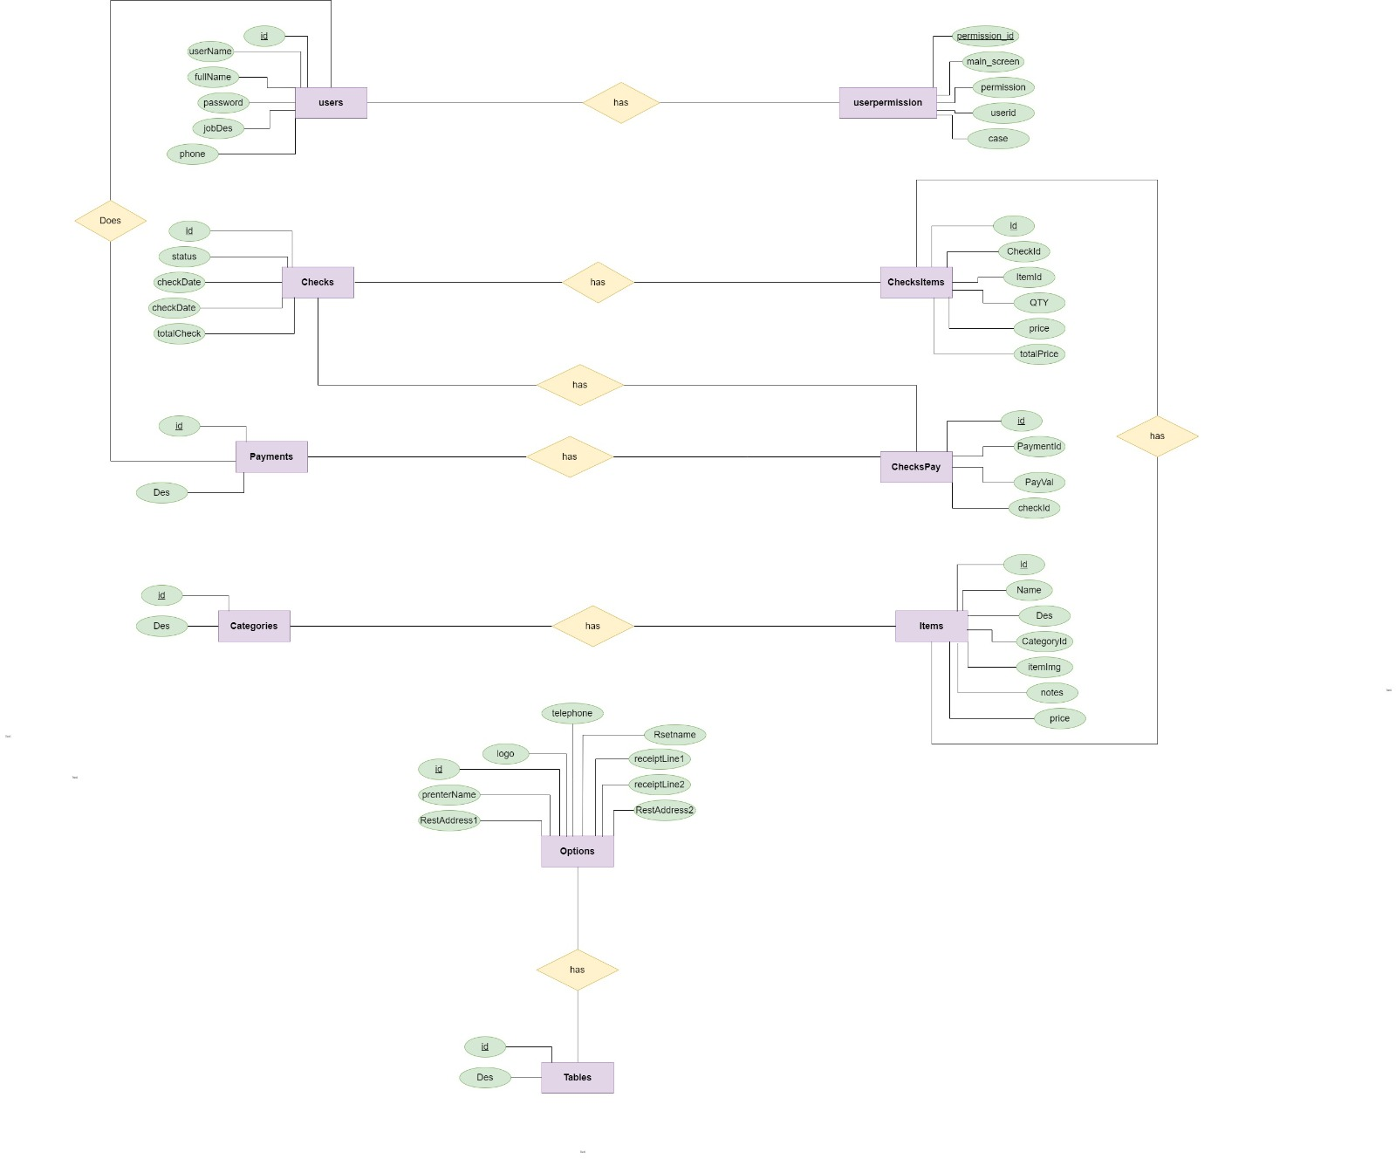

**A summary of the application interfaces :**

|  |  |
| --- | --- |
| **interface** | **Description** |
| **Login** | It is the entry interface to the program and the first interface that appears to the user |
| **Main** | It is the interface that brings together all parts of the application |
| **Point of Sale** | It is the interface that contains the cashier and Payments and Tables |
| **Setup From** | It is the interface that contains categories and ways to add them, elements and their addition in the application, users and their permissions, and payments |
| **Reporting** | It is the interface that contains everything related to system reports. |
| **Options** | It is the interface that contains information about the system user, whether it is a restaurant or cafe |
| **Add Category** | It is an interface used to add categories to the application |
| **Add Item** | It is an interface used to add items to the application |
| **Add User** | It is an interface used to add User to the application |
| **Add permission** | It is an interface used to assign Permission to User |
| **Add tables** | It is an interface used to add Tables to the application |

**Login From**

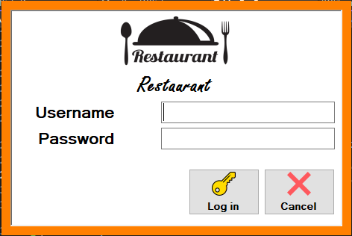

**Main From**

**It is the interface that brings together all parts of the application**

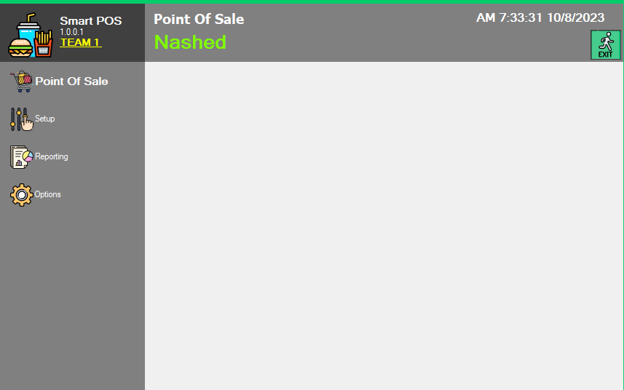

**Point of Sale From**

**It is the interface that contains the cashier and Payments.**

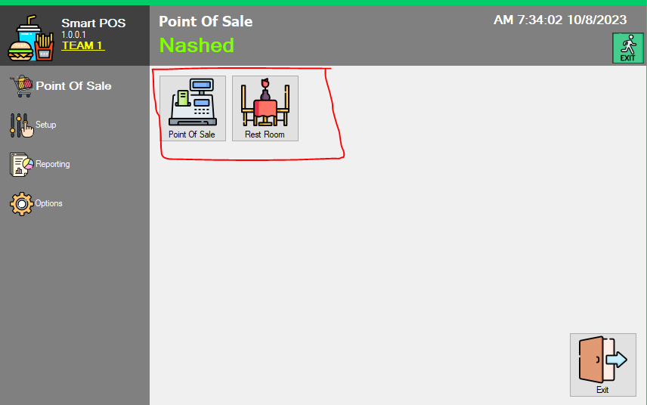

**Setup From**

**It is the interface that contains categories and ways to add them, elements and their addition in the application, users and their permissions, and payments**

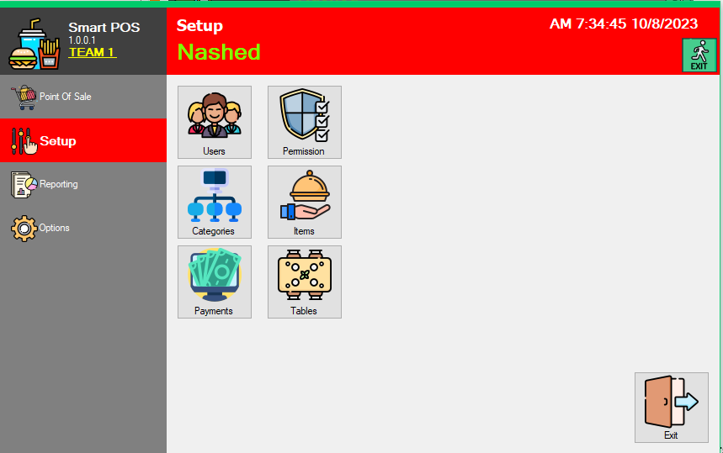

**Reporting From**

**It is the interface that contains everything related to system reports.**

**Options From**

**It is the interface that contains information about the system user, whether it is a restaurant or cafe**

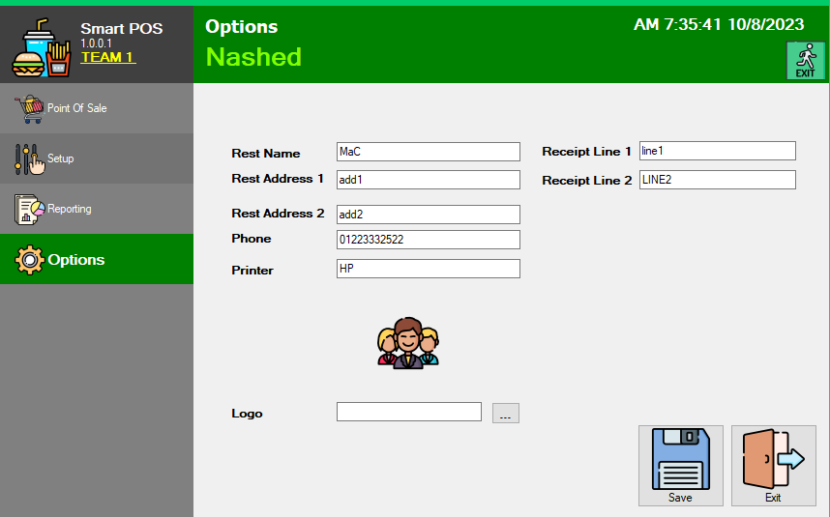

**Add Category**

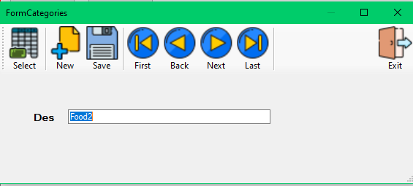

**Add Items**

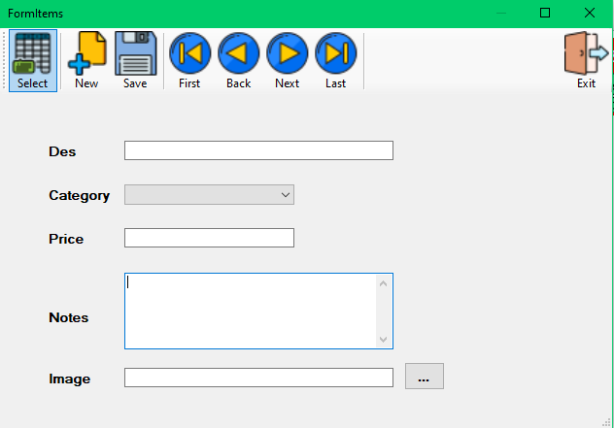

**Add payment methods**

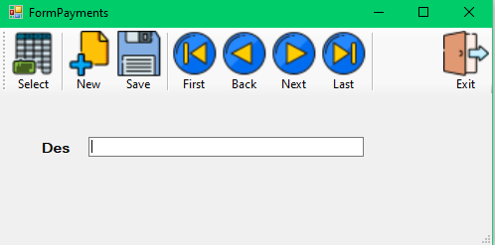

**Add Tables**

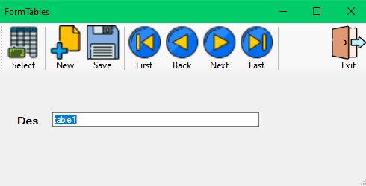

**Add User**

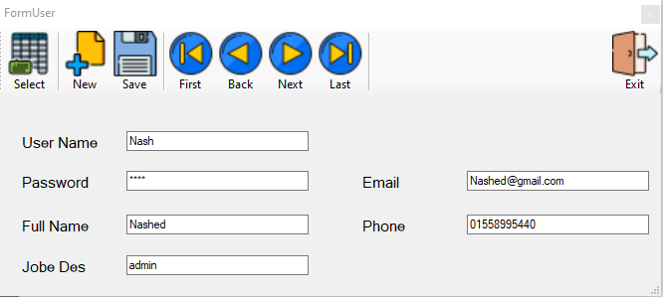

**

**Tables Form**

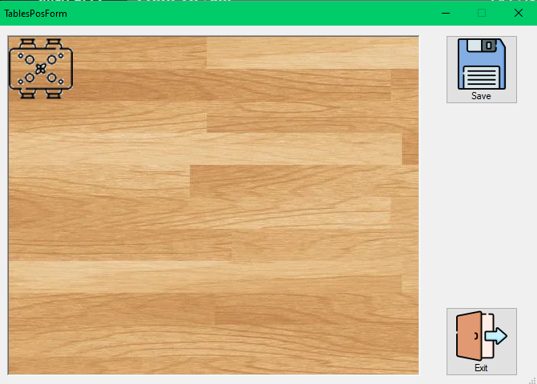

**Point Of Sale Form**

**Receipt Form**

**Receipts Done Between Date Form**

